**Troubleshooting Guide**

**My motors are locked on powerup but they do not move.**

* Check to make sure the PUL and DIR pins are secured to your arduino. PUL pulses to make the motor move and DIR is either high or low to determine direction.
* Check to make sure coil A and coil B are connected to the driver. Each stepper motor has 4 wires. Two wires are for coil A and the other two are for coil B. Typically the red and blue wire are a coil and the green and black wire are the other coil, THIS IS NOT ALWAYS THE CASE. To be sure, use a continuity meter to determine the coils. Two wires that make continuity are a coil.

**I Cannot Connect to Openbuilds**

* Firmware needs to be installed on the arduino to be able to establish connection. Refer to **[5] Electronics and Software** for instructions on how to install the firmware. If you are not able to do either make sure that the USB cable you are trying to connect with is able to send data and not a charging cable.
* Be sure that you are connecting to the correct COM port in openbuilds. If you are not connected to the correct COM port you will not be able to flash firmware or connect to the arduino. To change the COM port select the dropdown arrow. You do not need to remove the USB cable from your computer.

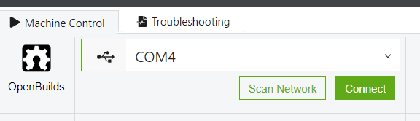

* If this does not work, you may have to install grbl manually. For instructions on how to do this refer to this link. <https://inventables.zendesk.com/hc/en-us/articles/360012725634-How-do-I-re-flash-Grbl-to-my-X-Controller-Arduino->